**AANDROID BLOOD BANK**

**BLOOD BANK MANAGEMENT SYSTEM….**

# OUTLINE

* Introduction
* Problem Statement
* Aims and Objectives
* Methodology of Research
* Result Expected
* Utilization of Research
* Work Progress
* Software used

# INTRODUCTION

* The main aim of this project is to save lives of people by providing blood.
* Our project Online Blood Bank system using Android is developed so that users can view the information of nearby hospitals, blood banks and volunteer donors.
* This project is developed by four perspectives i.e. hospital, bloodbank, volunteer donors and patient.
* This application we are developing helps to select the nearby hospitals, bloodbanks, donors online instantly by tracing its location using GPS.
* This application reduces the time to a greater extent that is searching for the required blood through blood banks and hospitals.
* Thus this application provides the required information in less time and also helps in quicker decision making.

# PROBLEM STATEMENT

Problem

 The major problem in old Blood banking systems was that, they don’t follow the actual needs of users.

* Traditional blood banking systems were developed by 1 or 2 perspective.
* Tracking the database was complicated when the details are maintained manually.
* There was shortage and sometimes unavailability of rare blood groups due to less modules i.e. patient and donors.

Solution

* A better idea is to use the application which Mobile device is very popular with people too.
* This application is providing each entity the facility to approach nearby blood donors so that it will become much easier to search rare blood groups in the hour of need.

# AIMS & OBJECTIVES

* To bridge the gap between blood banks, hospitals, volunteer donors and needy people, through this system.
* To facilitate the search process for needy people and make it easier than before.
* To reduce the data entry process.
* To use GPS service for locating the hospitals, blood banks & volunteer donors to know if the seeker is near to or not.
* Some blood types are rare so the system can find the required donors with the required blood type easily from the huge database by using search feature in the android app.
* To provide dynamic database that is storing donors Information and can communicate with them easily.

# METHODOLOGY OF RESEARCH

*Theoretical Studies*

The theoretical study requires in depth knowledge of following fields:

* In depth knowledge about existing Android Blood banking systems
* Requirement elicitation through comparison of android-based existing blood bank systems
* Knowledge about available tools used for development of android applications

RESULTS EXPECTED

Proposed android application framework will be better than any existing android based blood bank application in implementation as well as performance point of view.

GPS and nearest neighbor algorithm helps patients to find and request nearby hospitals. Also helps Blood bank's and Hospitals to find and request volunteer donors nearer to the location from where the request for the blood is generated.

UTILIZATION OF RESEARCH RESULTS

To make android technology more friendly for the patients, blood banks, hospitals and volunteer donors in context of blood donation and blood transfusion.

○ To save lives by rapid access to blood related information anytime, anywhere.

S

YSTEM

M

ODEL

Implementation and Evolution of Mobile Quiz Application to Overcome Existing

Usability Loopholes

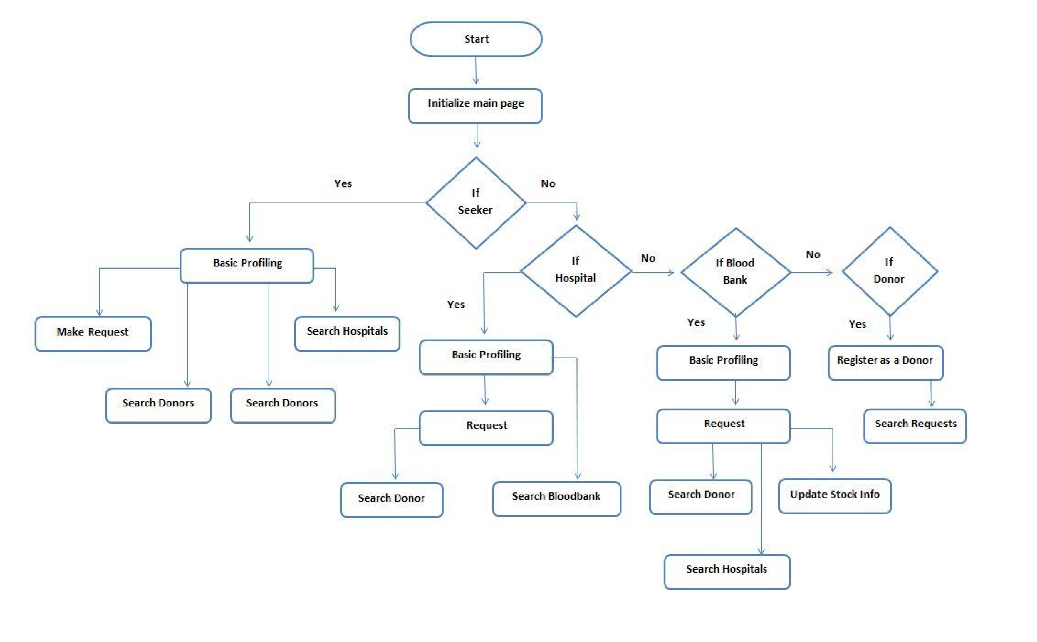

DATABASE DESIGN USE CASE DIAGRAM…

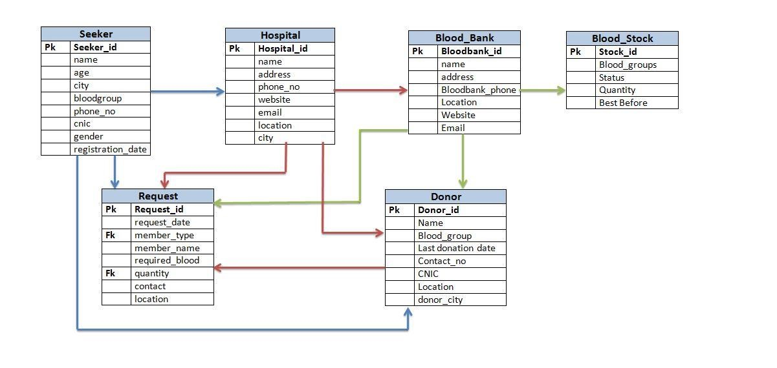

APPLICATION SCREENSHOTS

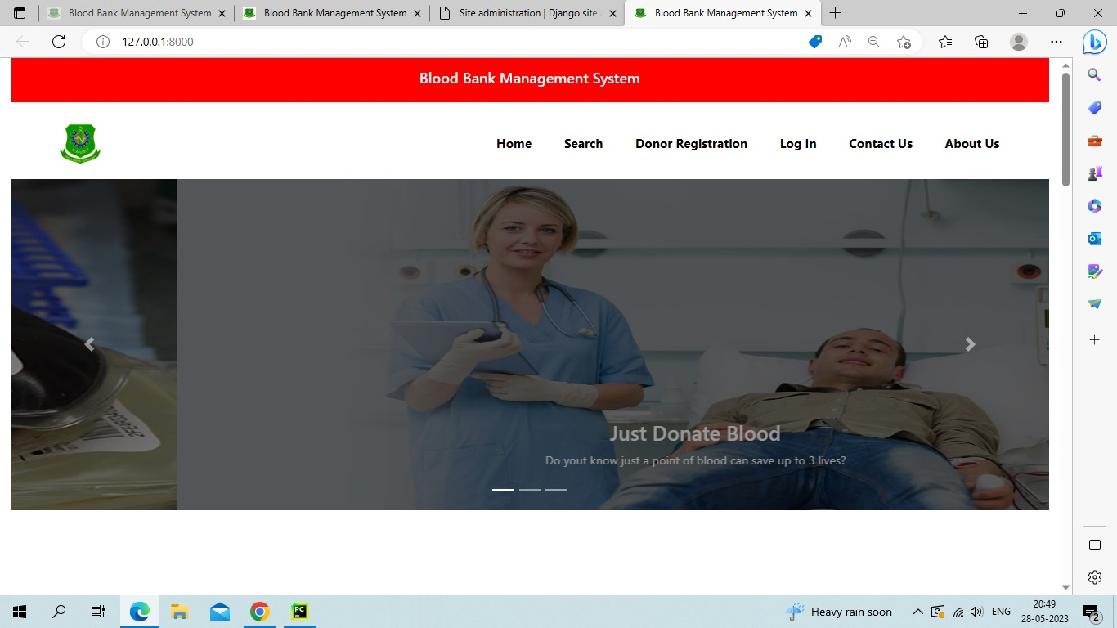

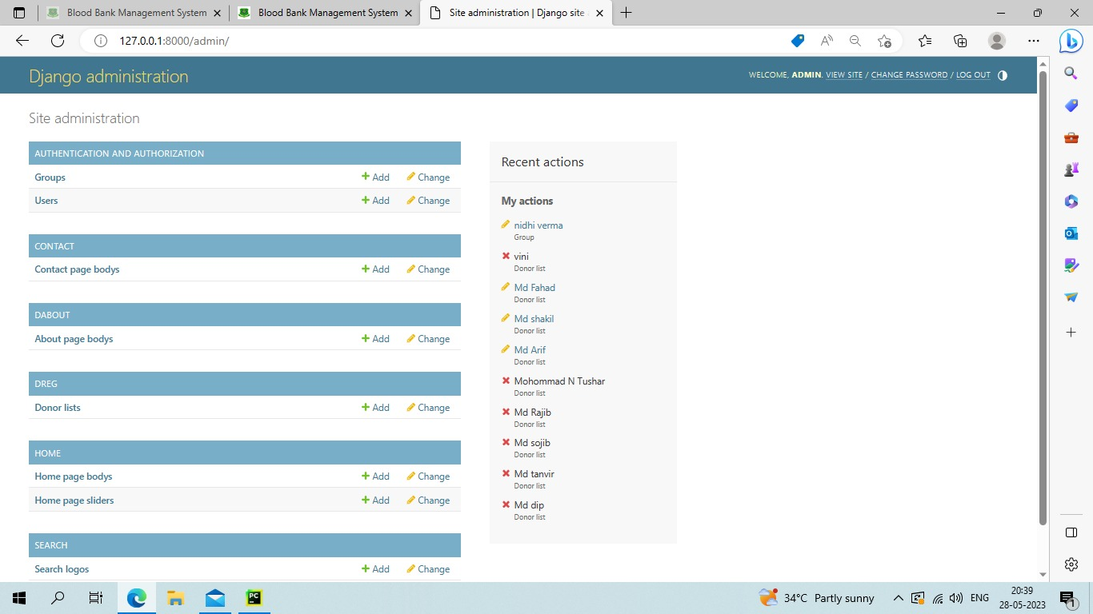

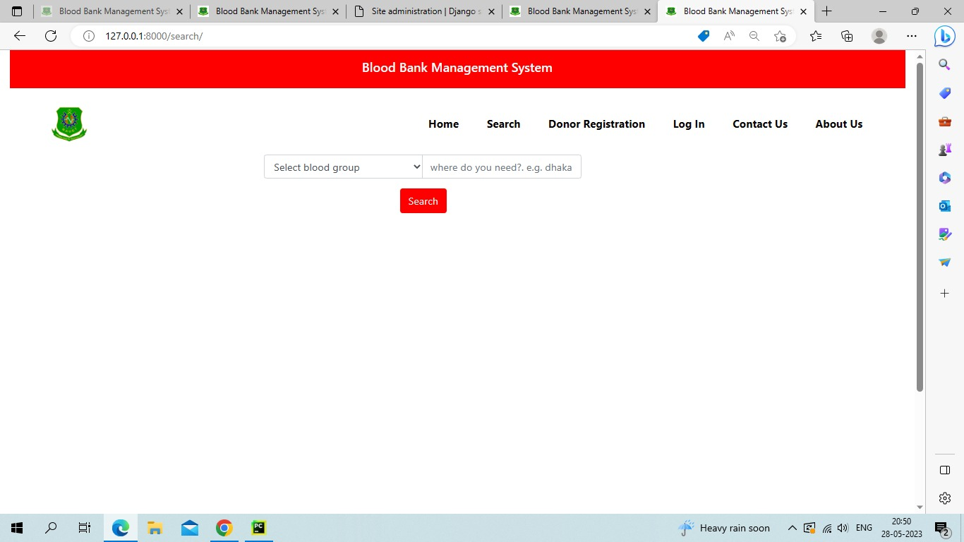

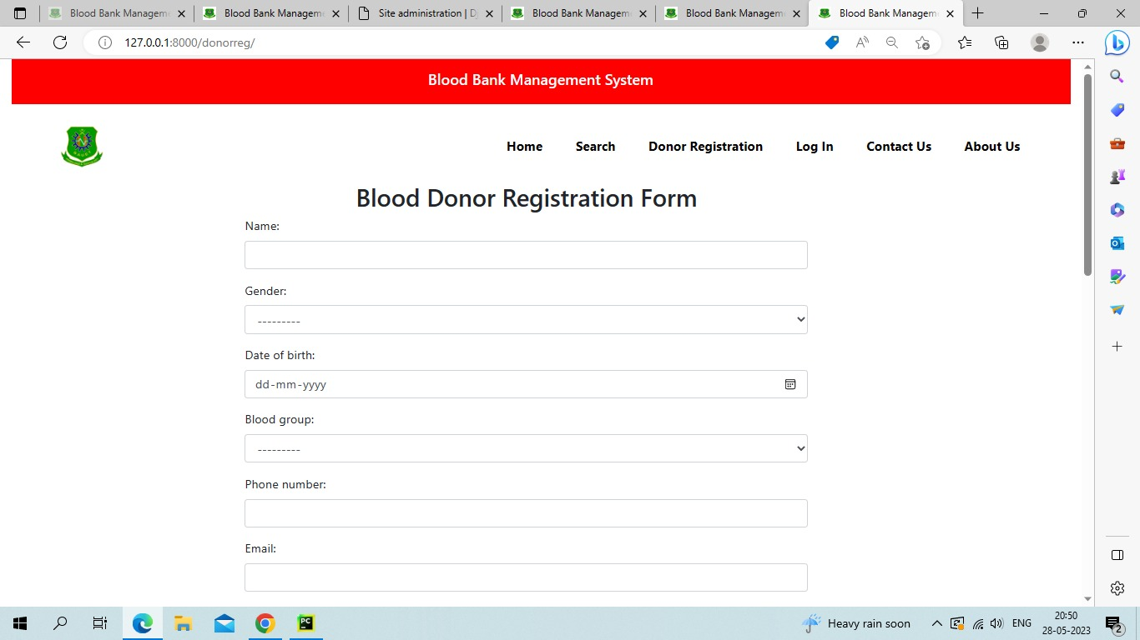

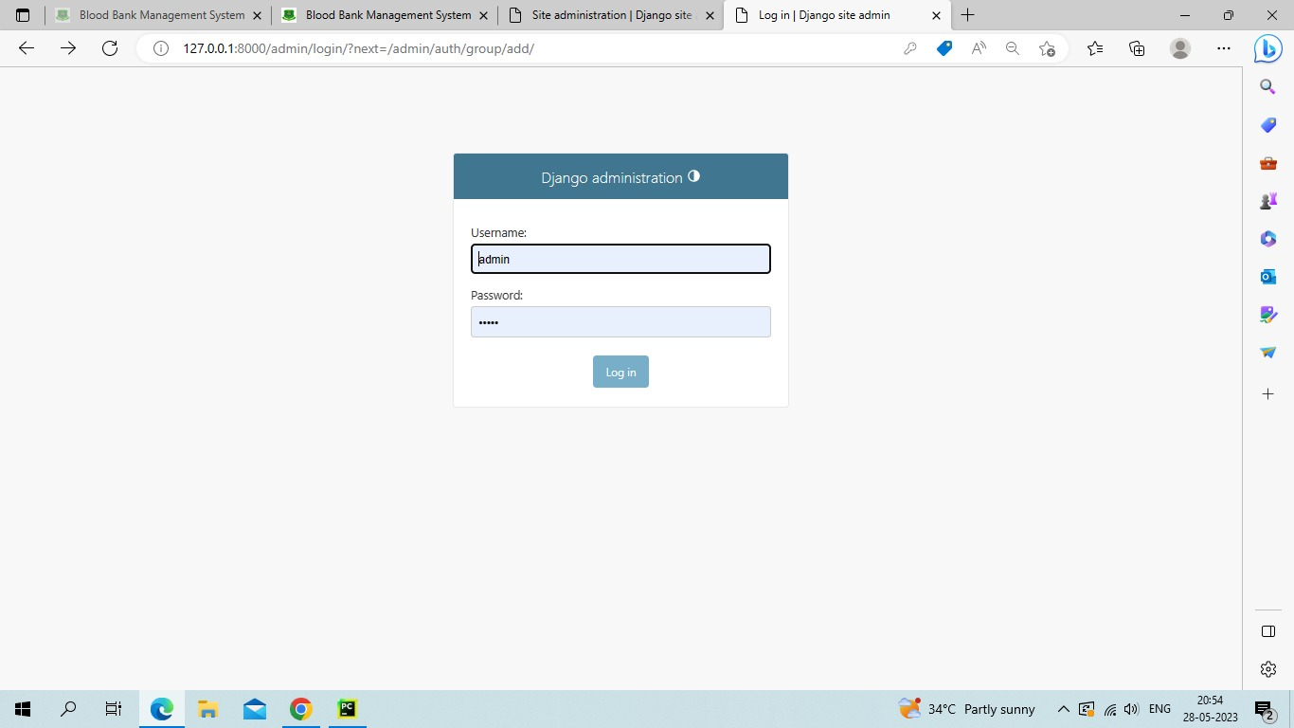

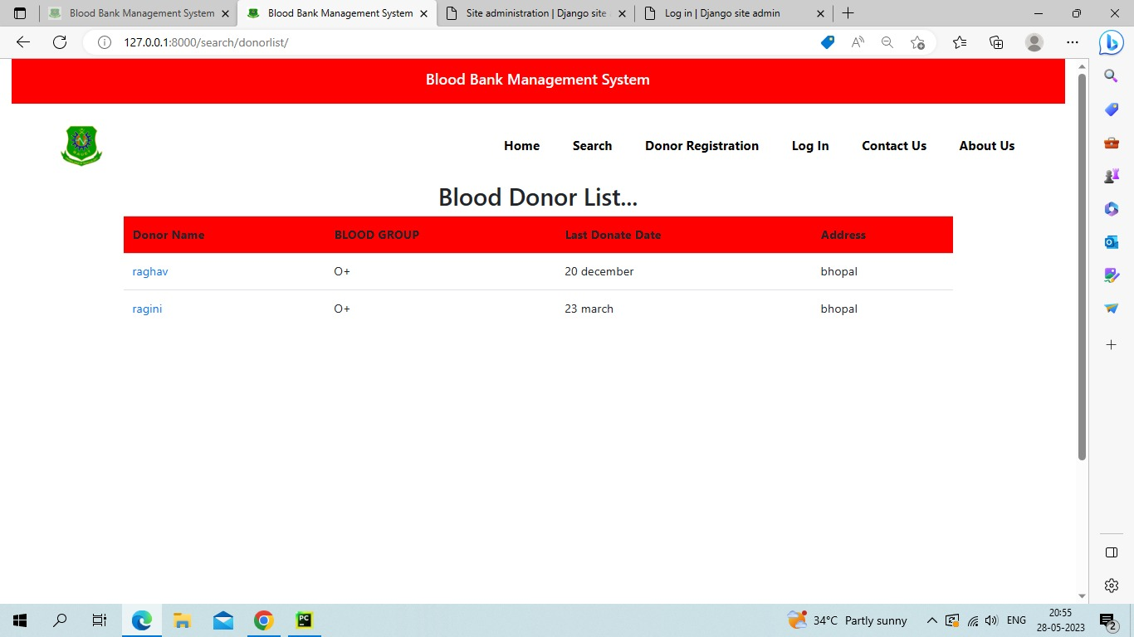

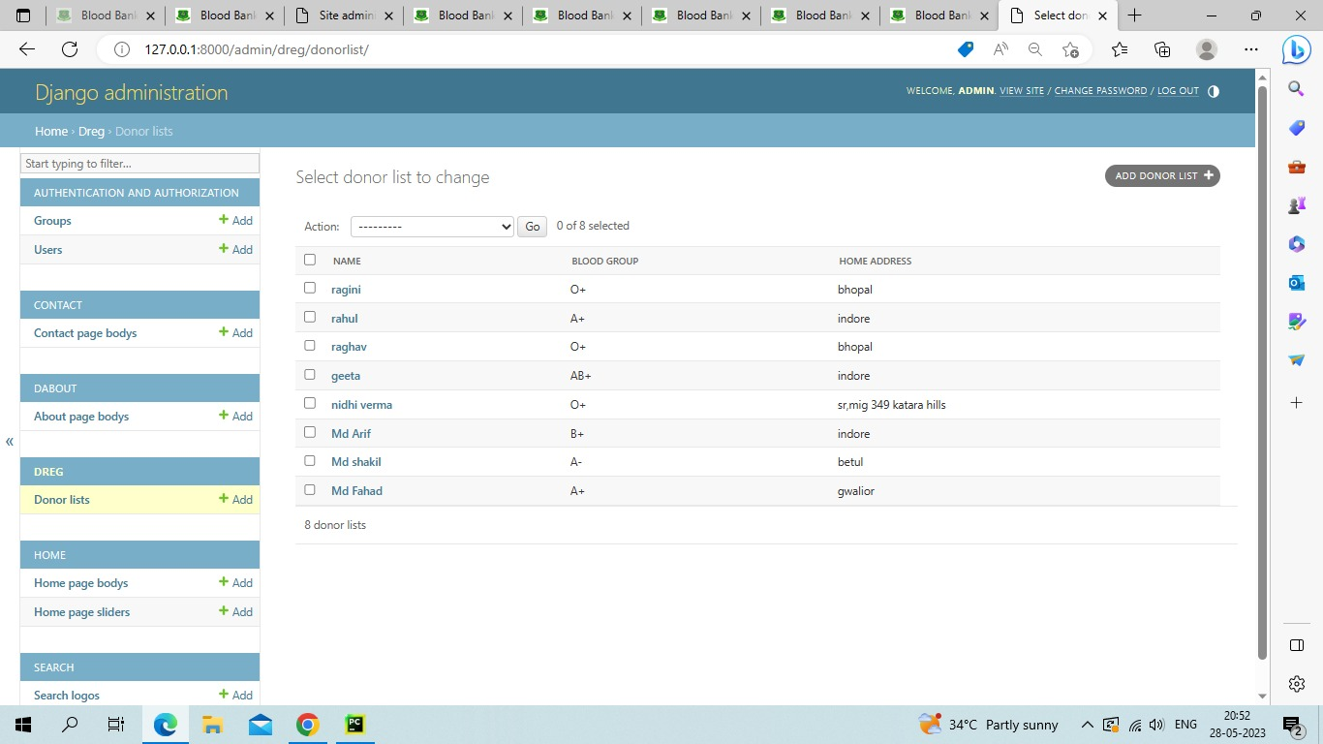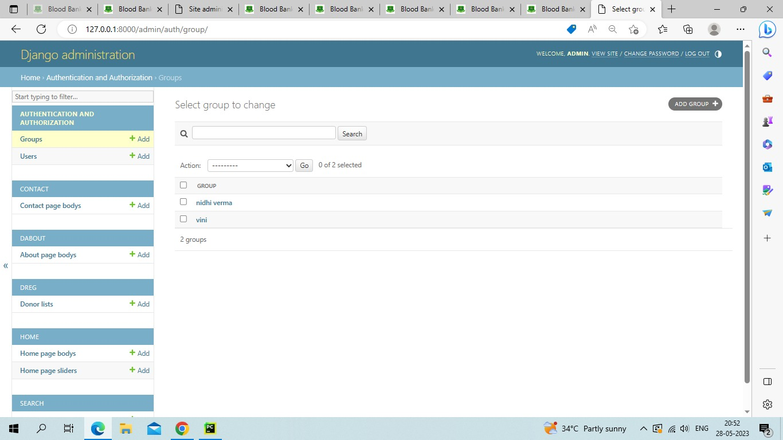

**SOFTWARE USED…**

* Python
* Django
* HTML/ CSS
* SQL lite

**Thank you…..**